**Week 6**

**2.ReactJS – HOL**

**FILE STRUCTURE  
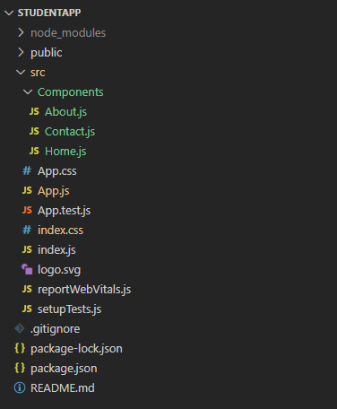  
  
CODE**

*C:\Users\User\Desktop\studentapp\src\Components\Home.js*

import React, {Component} from 'react';

class Home extends Component{

    render(){

        return(

        <div>

        <h3> Welcome to the Home Page of Student Management Portal </h3>

        </div>

    );

 }

}

export default Home;

*C:\Users\User\Desktop\studentapp\src\Components\About.js*

import React, {Component} from 'react';

class About extends Component{

    render(){

        return(

        <div>

        <h3> Welcome to the About Page of Student Management Portal </h3>

        </div>

    );

 }

}

export default About;

*C:\Users\User\Desktop\studentapp\src\Components\Contact.js*

import React, {Component} from 'react';

class Contact extends Component{

    render(){

        return(

        <div>

        <h3> Welcome to the Contact Page of Student Management Portal </h3>

        </div>

    );

 }

}

export default Contact;

*C:\Users\User\Desktop\studentapp\src\App.js*

import logo from './logo.svg';

import './App.css';

import Home from './Components/Home';

import About from './Components/About';

import Contact from './Components/Contact';

function App() {

  return (

    <div className="container">

      <Home/>

      <About/>

      <Contact/>

    </div>

  );

}

export default App;

**OUTPUT**

